**PRACTICAL-1:**

**HPTLC: HIGH PERFORMANCE THIN LAYER CHROMATOGRAPHY**

**Date: 27/7/2022**

**AIM:**

To quantitate DFS (Diclofenac sodium) from single formulation (Voveran) using High Performance Thin Layer Chromatography (HPTLC)

**INTRODUCTION:**

Chromatography is one of the techniques used for the separation of the components from the sample. Thin-layer chromatography is without doubt one of the most versatile and widely used separation methods in chromatography. The concept of HPTLC is simple and samples usually require only minimal pre-treatment. It has been frequently used in pharmaceutical analysis, clinical analysis, industrial chemistry, environmental toxicology, food chemistry, pesticide analysis, dye purity, cosmetics, plant materials, and herbal analysis. Today, most stages of this technique are automated and operated instrumentally in the form of modern high-performance thin-layer chromatographic system that allows the handling of a large number of samples in one chromatographic run. Speed of separation, high sensitivity, and good reproducibility result from the higher quality of chromatographic layers and the continual improvement in instrumentation. It is now capable of handling samples with minimal pre-treatment, detecting components at low nanogram sensitivities and with relative standard deviations of about 1%. HPTLC is now truly a modern contemporary of HPLC and GC and continues to be an active and versatile technique in research with large number of publications appearing each year.

The HPTLC technique is an automated and sophisticated form of thin layer chromatography with superior and advanced separation efficiency and detection limits and is often an exceptional alternative to high-performance liquid chromatography (HPLC) and gas chromatography (GC). The high-performance thin-layer chromatography is also known as flat-bed chromatography or as planar chromatography. The HPTLC works on the same principles as TLC such as the principle of separation is adsorption. The mobile phase or solvent flows through the capillary action. The analytes move according to their affinities towards the stationary phase (adsorbent). The higher affinity component travels slower towards the stationary phase. A low-affinity component travels rapidly toward the stationary phase. On a chromatographic plate, then, the components are separated. HPTLC technologies are also the most appropriate TLC technique for conformity with GMPs. HPTLC remains one of the most flexible, reliable, and cost-efficient separation techniques ideally suited for the analysis of botanicals and herbal drugs. Used with standardized procedures, it guarantees reproducible results, a vital element in the routine identification of complex fingerprints of plant extracts and pharmaceutical products. The use of modern apparatus such as video scanners, densitometers, and new chromatographic chambers, and more effective elution techniques, high-resolution sorbents with selected particle size or chemically modified surface, the possibility of combining with other instrumental methods, and development of computer programs for method optimization all make HPTLC an important alternative method to HPLC or gas chromatography. It has established itself as the method of choice for handling complex analytical tasks involving herbal drugs and botanicals. The unique combination of state-of-art instrumentation, standardized procedures, and solid theoretical foundations enables it to deliver reliable, cGMP-compliant results time after time.

**Diclofenac sodium** is non-steroidal anti-inflammatory drug (NSAID) which is used to treat minor aches and used as an analgesic to reduced pain. It is available as sodium and potassium salts. It is available as a generic drug in a number of formulations.

**Uses of Diclofenac sodium**

* Treatment of pain, inflammation disorders.
* It is used in treatment of various type of arthritis.
* It is also used in treatment of chronic disorder and acute non-bacterial inflammation of anterior part of eye.
* It is used in pain management in case of kidney and gall stone and also in case of active migraines.

**Side Effects**

DFS may cause side effects. Common side effects with DFS are stomach pain, constipation, diarrhea, heart burn or indigestion, headache, nausea, etc.

Contradiction: Hypersensitivity against Diclofenac inflammatory intestinal disorders such as ulcerative colitis, severe renal insufficiency

**Action of DFS**

It works by blocking the action of cyclooxygenase which is involved in production of prostaglandin. This prostaglandin produced in response to injury or certain diseases and would otherwise go on to cause pain.

**Principle:**

HPTLC works on the same principles as TLC such as the principle of separation is adsorption. The mobile phase or solvent flows through the capillary action. This separation relies on the relative affinity of compounds towards both the phases. The compounds in the mobile phase move over the surface of the stationary phase. It is based on the principle of adsorption chromatography or partition chromatography or a combination of both depending on the adsorbent, its treatment, and the nature of solvents employed. The compounds with higher affinity to the stationary phase will move slowly and the compounds with lower affinity to the stationary phase will move fast. Hence, the separation of the mixture is attained. On the completion of the process, the individual components will appear as spots at respective levels on the plates.

**THEORY:**

Experimental Procedure of HPTLC –

1. Sample preparation: This requires a highly concentrated solution since much less sample quantity needs to be applied. The plate’s solvents must be non-polar of the volatile type. Polar solvents are commonly used to dissolve samples for reversed-phase chromatography.
2. Selection of Chromatographic Layers: The layer of HPTLC is available in the form of very fine particle size silica gel pre-coats which is widely used as adsorbent. The plates are similar to conventional TLC plates. Here silica gel of very fine particle size is widely used as adsorbent. The use of particle size helps in greater resolution and sensitivity. Plates are produced from 4 to 5 mm silica gel with an inert binder to form a 200mm layer. Plates of 20x20cms are 5x7.5cms is used.
3. Pre-washing: Plates need to be washed to remove water vapours or volatile impurities. The plated are cleaned by methanol.
4. Conditioning: The pre washed plates are placed in oven at 120°c for 15 to 20 mins. This process is known as conditioning.
5. Sample application: The size of the sample spot applied must not exceed 1mm in diameter. There are different techniques for the spotting of sample; one of them is self-loading Capillary in which small volume of samples may be applied to the plate. Surface using platinum- iridium tubing fused into the end of a length of glass tubing.
6. Pre-Conditioning: Saturation is necessary for highly polar mobile phases although there is no need for saturation for low polarity mobile phases.
7. Mobile Phase of HPTLC: Through trial and error, the mobile phase of the suitable solvents is to be selective.
8. Chromatographic Development: The linear development method in high-performance thin-layer chromatography is the most common technique here the plate is positioned vertically in an appropriate container with a solvent or mobile phase. The mobile phase is generally fed by capillary action and both sides may produce chromatograms.
9. Detection of spot and Scanning: The HPTLC instrument has attached to computer and data recording devices. The development of spots is viewed as peaks at wavelengths of selected UV regions. The height and the area of the peaks are determined by the instrument and recorded as a percentage.

**REQUIREMENTS:**

1. Apparatus
2. Standard ambered volumetric flask (50 ml),
3. Pipettes (1ml, 5ml),
4. Hamilton syringe (100µl).
5. Chemicals
6. Methanol (HPLC grade)
7. Miscellaneous
8. Mortar and Pestle
9. Voveran 50 mg tablet
10. Instruments
11. CAMAG HPTLC set up with visionCATS software
12. Automatic sample applicator

**PROCEDURE:**

1. Sample preparation:

1. Take an entire tablet of Voveran and weigh it.
2. Crush it in a mortar and pestle.
3. Weigh it again and transfer the entire content to a standard 50mL ambered volumetric flask.

2. Plate development: A silica gel coated aluminum plate was used of pore size 60 and fluorescence at wavelength 254 nm (60F254) made by the brand E Merck.

3. Load samples and standards using an automated sample applicator.

4. Place the plate in a 20 x 10 twin trough chamber containing the mobile phase for 20 minutes.

5. Perform scanning and detection under UV light using visionCATS software.

**Chromatographic conditions**:

|  |  |  |
| --- | --- | --- |
| **Sr no.** | **Parameter** | **Specification** |
| 1. | Instrument | visionCATS Planar chromatography software |
| 2. | Stationary phase   1. Plate size 2. Plate type 3. Indicator | 1. 20 x 10 2. Silica coated aluminum sheet 3. Silica gel 60F254 (E. Merck) |
| 3. | Sample | Voveran tablet |
| 4. | Standard | Diclofenac sodium |
| 5. | Sample and standard volume | 10μL |
| 6. | Band length | 8mm |
| 7. | Track distance | Automated |
| 8. | Mobile phase | Toluene: Ethyl Acetate: Glacial Acetic acid (6:4:0.1 for a 10 x 10 plate) |
| 9. | Chamber size | 20 x 10 Twin trough |
| 10. | Saturation time | 20 minutes |
| 11. | Solvent front | 90mm (9cm) |
| 12. | Detection (λmax) | 281nm |
| 13. | Number of tracks | 10 |

**OBSERVATIONS AND RESULTS:**

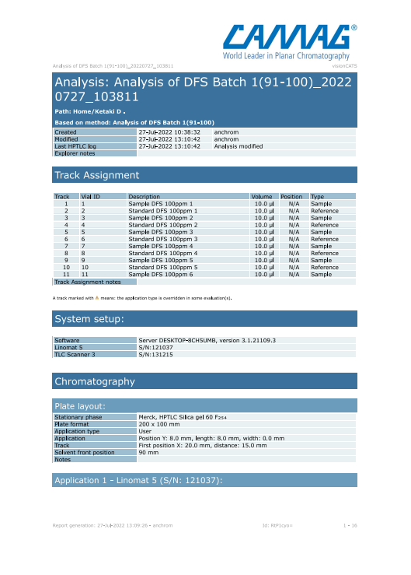

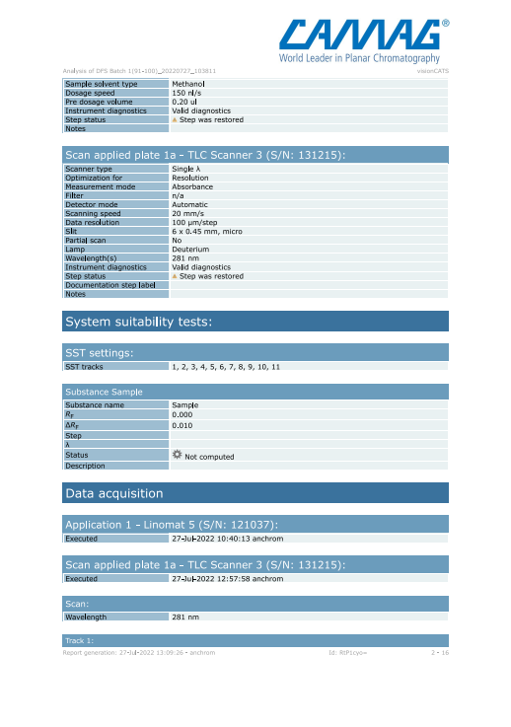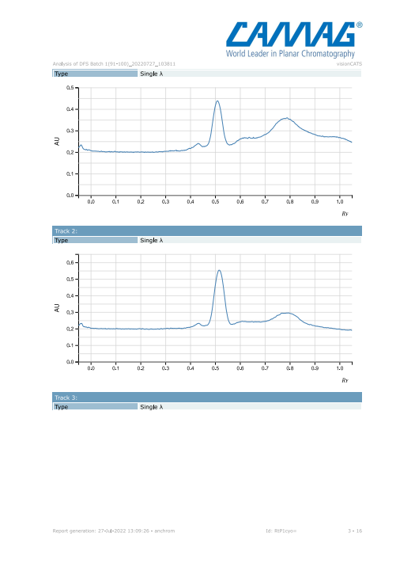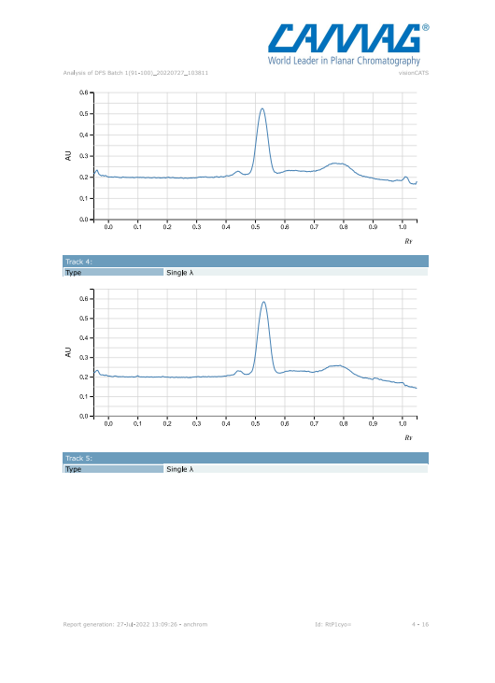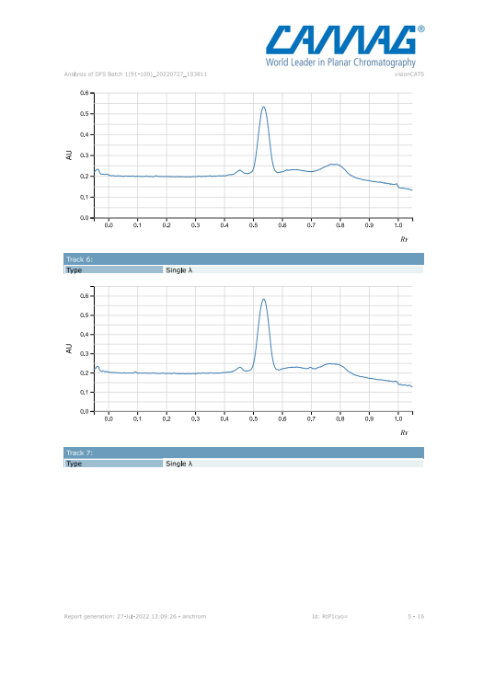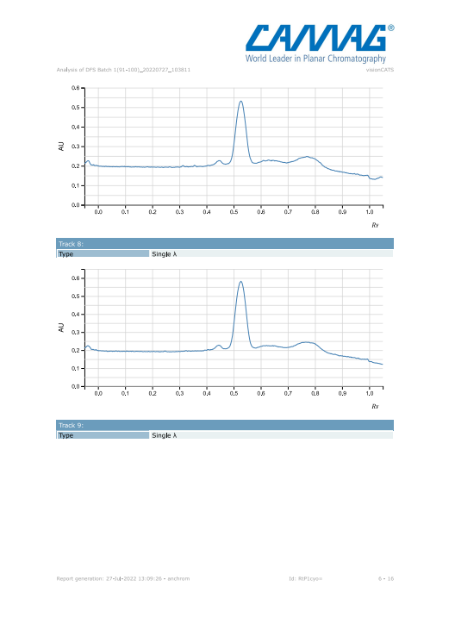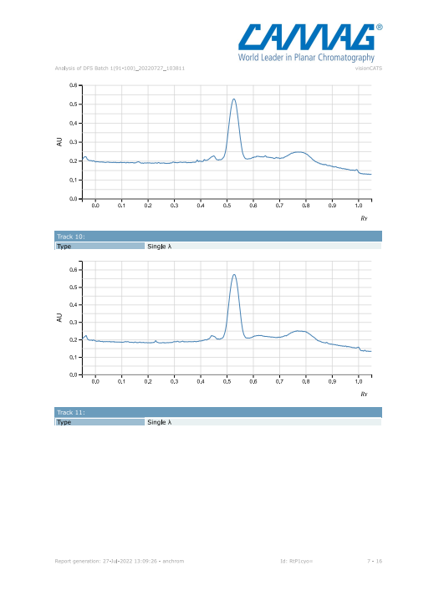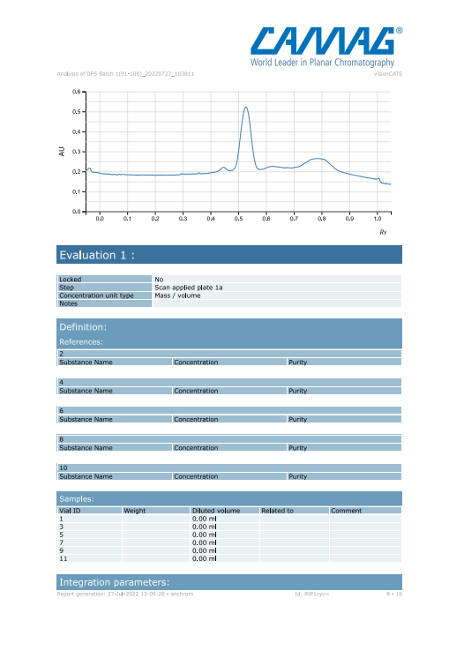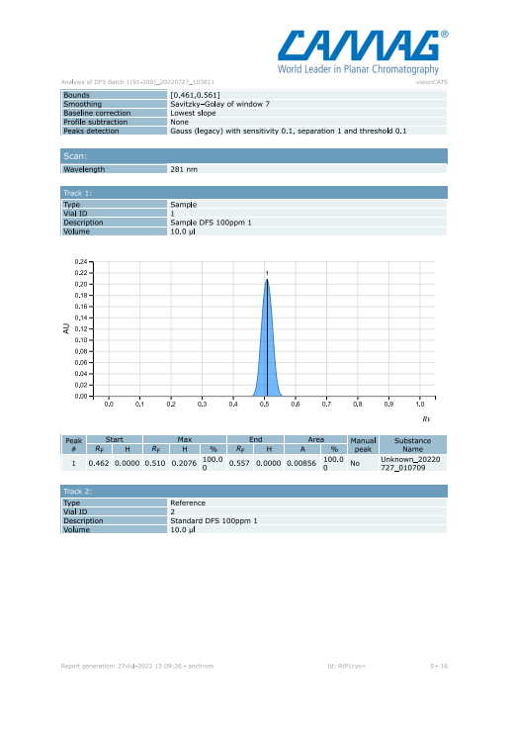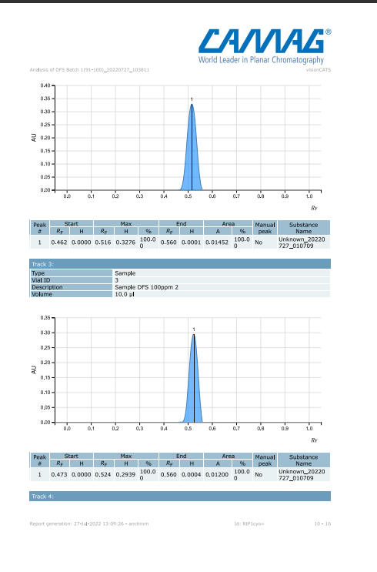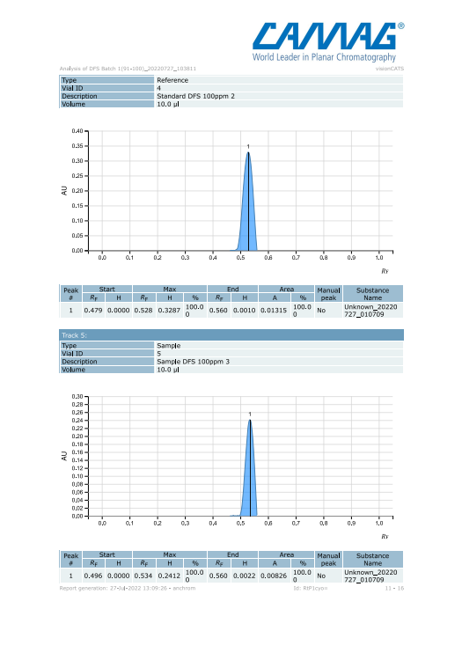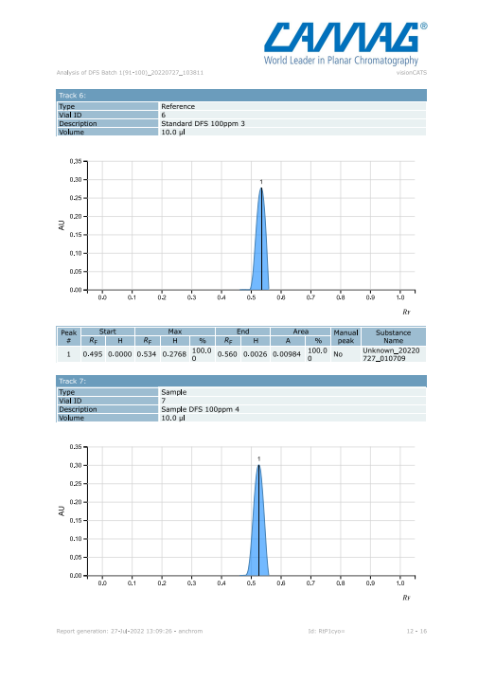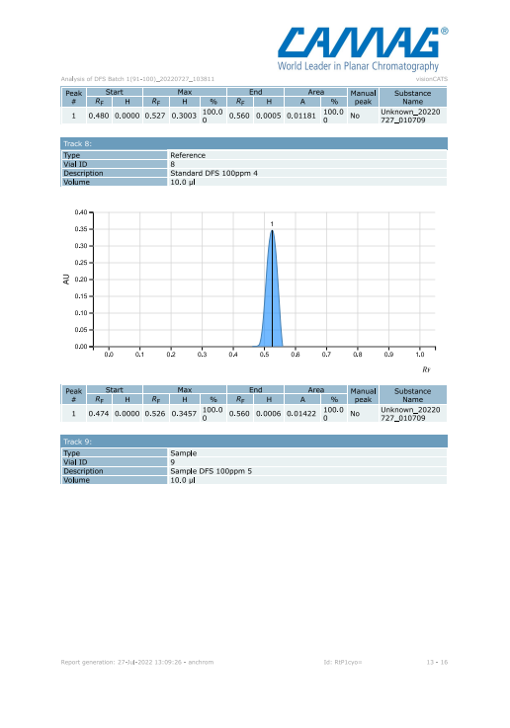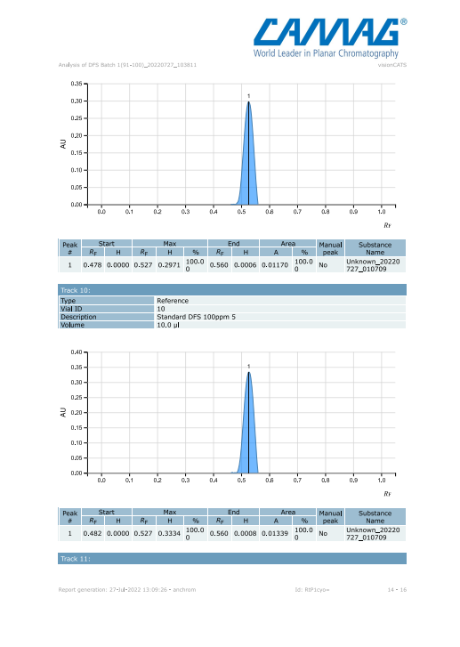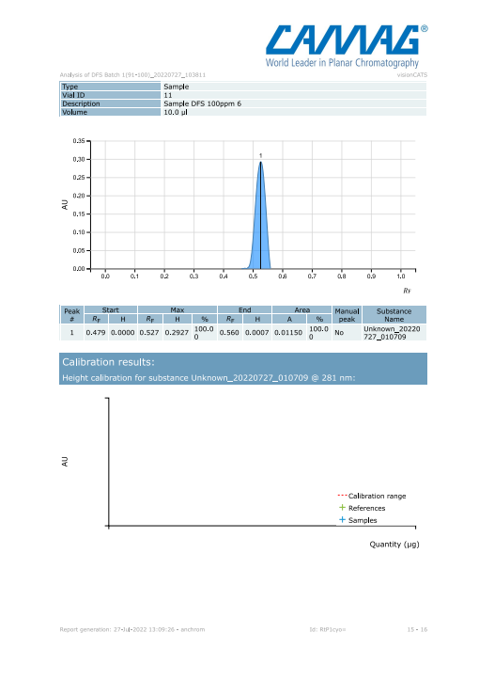

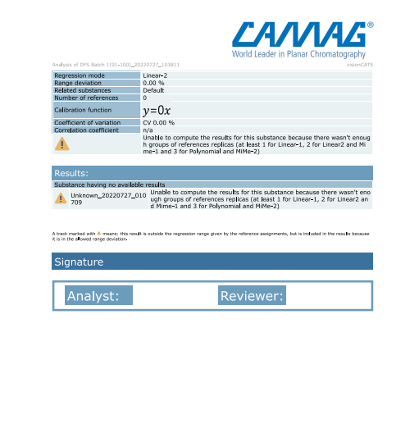

**CONCLUSION:**

Low cost, faster speed, satisfactory precision and accuracy are the main features of this method. DFS (Diclofenac sodium) was quantitated from single formulation (Voveran) using High Performance Thin Layer Chromatography (HPTLC).

**PRACTICAL 2**

**HIGH PERFORMANCE LIQUID CHROMATOGRAPHY**

**DATE:30/09/22**

**AIM**

To separate Diclofenac sodium from its combination formulation (Dicloran A) using HPLC.

**INTRODUCTION:**

Chromatography is an analytical technique where a sample sample mixture is separated is separated into its individual component. High Performance Liquid Chromatography (HPLC) is one such mode of chromatography. It involves Mass-transfer between stationary and mobile phase. HPLC utilizes a liquid mobile phase and solid / liquid stationary phase to separate the components of a mixture. The sample is first dissolved in a solvent and forced to flow through a chromatographic column under high pressure. In the column, the mixtures separate into its components. The column is packed with the stationary phase composed of irregularly or spherically shaped particles. The amount of resolution is important and is dependent on the extent of interaction between the solute components and both the phases. As a result, HPLC acquires a high degree of versatility not found in other chromatographic system and it has the ability to easily separate a wide variety of chemical mixture.

# INSTRUMENTATION

HPLC instrumentation includes a pump, injector, column, detector and data acquisition system. The heart of the system in column, where the separation occurs since the stationary phase is composed of micrometer size porous particles. A high pressure pump is required to move the mobile phase through the column. Eventually each component elutes from the column as a narrow band and is recorded by the recorder. Detection of the eluting compound is important. The response of detector is displayed on a chart recorder or computer screen and is known as chromatogram.

# Stationary Phase

Modern HPLC stationary phases are made up of small rigid porous particles with high surface area. Particle size 3 to 10 micrometers. Particle size distribution as narrow as possible depending on the type of ligand attached to the surface. The adsorbent could be normal phase (-OH, -NH2) or reversed phase and even anion or cation exchanger.

# Mobile Phase

In HPLC, the types of band composition of eluent is one of the variable influencing the separation of the particles should be purity, detector compatibility, solubility of sample, low viscosity, chemical inertness.

The HPLC instrument includes the following components-

* **PUMP**
  1. The role of the pump is to force a liquid (called the mobile phase) through the liquid chromatography at a specific flow rate, expressed in millimeters per min (ml / min).
  2. Normal flow rate in HPLC are in the 1 to 2 ml / min range.
  3. Typical pumps can reach pressure in the range of 6000 – 9000 psi (400 to 600 bar).
  4. During the chromatographic experiment, a pump can deliver a constant mobile phase composition or an interest mobile phase composition (gradient)
* **INJECTOR**
  1. The injector serves to introduce the liquid sample into the flow stream of the mobile phase.
  2. Typical sample volume are 5 to 20 microlitre.
  3. The injector must also be able to withstand the high pressure of the liquid system.
  4. An auto sampler is the automatic version for when the user has many samples to analyse or when manual injection is not practical.
* **COLUMN**
  1. Consider the “heart of the chromatograph” – the column’s stationary phase separates the sample components of interest using physical and chemical parameters.
  2. The small particles inside the column are what cause the high pressure at normal flow rates.
  3. The pump must push hard to move the mobile phase through the column and this resistance cause a high pressure within the chromatograph.
* **DETECTOR**
  1. The detector can detect the individualanalyte that come out (elute) from the column.
  2. A detector serves to measure the amount of these molecules so that the chemist can quantitatively analyse the sample components.
  3. The detector provides an output to a recorder or computer that result in the liquid chromatogram (i.e. the graph of the detector response).
* **COMPUTER**
  1. Frequently called the data acquisition system.
  2. The computer not only control the all the modules of HPLC but it takes the signal from the detector and uses it to the signal to determine the time of elution (retention time) of the sample components and the amount of sample (quantitative analysis).

**PRINCIPLE:**

Reversed phase HPLC is the most popular mode of chromatography. In reverse phase chromatography, the stationary phase is relatively non-polar than the mobile phase. The stationary phase is the liquid coated on inert solid support which is mostly silica. Hence the basic principle of reversed phase HPLC is partitioning between the stationary phase and mobile phase which flows through the column. In reverse phase, retention time is longer for molecules which are more non- polar while polar molecules elutes more readily. The retention time can be increased by adding more water to the mobile phase. This makes mobile phase more hydrophilic relative to the more hydrophobic stationary phase. Similarly, retention time can be decreased by adding more organic solvent to the mobile phase.

**APPLICATION OF HPLC**

Preparative HPLC refers to the process of isolation and purification of compounds. Important is the degree of solute purity and the throughput, which is the amount of compound produced per unit time. This differs from HPLC, where the focus is to obtain information about the compound. The information that can be obtained includes identification, quantification and resolution of a compound.

Chemical separation can be accomplished using HPLC by utilizing the fact that certain compounds have different migration rates given a particular column and mobile phase. Thus, the chromatographer can separate compounds from each other using HPLC, the extent or degree of separation is mostly determined by the choice of stationary phase and mobile phase.

Purification refers to the process of separating or extracting the target compound from other (possibly structurally related) compounds or contaminants. Each compound should have a characteristic peak under certain chromatographic conditions. Depending on what needs to be separated and how closely related the samples are, the chromatographer may choose the conditions such as the proper mobile phase, to allow adequate separation in order to collect or extract the desired compound as it elutes from the stationary phase. The migration of the compounds and contaminants through the column need to differ enough so that the pure desired compound can be collected or extracted without increasing any other undesired compound.

Identification of compounds by HPLC is a crucial port of any HPLC assay. In order to identify any compound by HPLC, a detection must be first selected. Once the detector is selected and its set to optimal detection setting, a separation assay must be developed. The parameters of this assay should be such that a clean peak of the known sample is observed from the chromatograph. The identifying peak should have a reasonable retention time and should be well separated from extraneous peaks of the detection levels which the assay will be performed. To alter the retention time of the compound, several parameters can be manipulated. The first is the choice of column, another is the choice column of mobile phase, and last is the choice in flow rate. Identification of a compound by HPLC is accomplished by researching the literature and by trail and error. A sample of a known compound must be utilized in order to assure identification of the unknown compounds. Identification of compounds can be assured by combining two or more detection method.

Quantification of compounds by HPLC is the process of determining the unknown concentration of a compound in a known solution. It involves injecting a series of known concentrations will give a series of peaks that correlate to the concentration of the compound injected.

**Diclofenac sodium** is non-steroidal anti-inflammatory drug (NSAID) which is used to treat minor aches and used as an analgesic to reduced pain. It is available as sodium and potassium salts. It is available as a generic drug in a number of formulations.

# USES OF DICLOFENAC SODIUM

1. Treatment of pain, inflammation disorders.
2. It is used in treatment of various type of arthritis.
3. It is also used in treatment of chronic disorder and acute non-bacterial inflammation of anterior part of eye.
4. It is used in pain management in case of kidney and gall stone and also in case of active migraines.

# SIDE EFFECTS

DFS may cause side effects. Common side effects with DFS are stomach pain, constipation, diarrhea, heart burn or indigestion, headache, nausea, etc.

Contradiction: Hypersensitivity against Diclofenac inflammatory intestinal disorders such as ulcerative colitis, severe renal insufficiency

# ACTION OF DFS

It works by blocking the action of cycloxygenase which is involved in production of prostaglandin. This prostaglandin produced in response to injury or certain diseases and would otherwise go on to cause pain.

# Formulation and Combination Formulation

Dicloran– Single Formulation. It contains only Diclofenac sodium as an API. Dichloran A – Combination Formulation. It contains Diclofenac sodium and paracetamol.

**REQUIREMENTS:**

# A.Apparatus -

* Standard volumetric flask (10ml, 25ml),
* Pipettes (1ml, 5ml),
* 25ml Schott bottles,
* 500ml beakers,
* Hamilton syringe (100µl). **B.Chemicals:**
* Methanol (HPLC grade),
* Acetonitrite (HPLC grade),
* 0.01M KH2PO4

# C.Miscellaneous

* Mortar and Pestle,
* Distilled water,
* Millipore filter,
* Filtering Assembly, **D.Instruments:**
* Sonicator,
* pH meter,
* **Shimadzu Prominence High Performance Liquid Chromatography**

**(HPLC) Gradient System.**

* Sample: Dicloran and Dicloran A tablets
* Standard: Diclofenac sodium (DFS)

**PROCEDURE:**

* Preparation of standard solution of DFS

1. Weigh 25 mg of standard DFS powder and dissolve it in a minimum amount of methanol and make volume up to 25ml in 25ml standard volumetric flask using methanol to make 1000ppm stock solution.
2. Pipette out 1ml of the above solution in a 10 ml of standard volumetric flask and make volume up to 10ml using 10ml methanol to prepare 100ppm solution.
3. Pipette out 1ml of the above solution in a 10 ml of standard volumetric flask and make volume up to 10ml using methanol to prepare 10ppm solution.
4. **Preparation of sample** 1.Weightablet of Dicloron A.
   1. Find out the average weight (so that the average weight corresponds to 50mg of DFS)
   2. Crush the tablet using mortar and pestle.
   3. Weigh the powder which gives **25mg of Diclofenac**and dissolve it in min. amount of methanol.
   4. Make the volume upto 25ml using methanol. Filter the solution through whatmann filter **paper no. 41**, this gives 1000ppm stock solution.
   5. Using this prepare 100ppm, 10ppm solution of Dicloran A.
5. **Preparation of Mobile Phase**

**1.**Prepare mobile phase by adding following solutions:

**Acetonitrile HPLC grade (ACN) : 0.01M KH2PO4(pH 3.5) in the ratio 70:30(v/v)**

1. Sonicate for 10mins.
2. Filter it through filteration assembly and again sonicate for 10mins.

# D.Preparation of Flushing Solution

1. HPLC grade **methanol: HPLC grade water** in the ratio 50:50 (v/v)
2. Sonicate for 10mins.
3. Filter it through filtering assembly and then sonicate for 10mins.

**Standard operating procedure for the operation of Shimadzu prominence hplc system**

# A.Operating procedure

1. Switch on the mains for UPS power supply.
2. Then press the ‘Test’ button on the Smart-UPS RT 2000.
3. Switch on the mains for the Shimadzu Gradient HPLC system.
4. Switch on the mains for the computer. Switch on the CPU.
5. Switch on the grey button with ‘Power’ written on them on the HPLC system. Each one to switch on the LC-20 AD. Pump and SPD-M20 A Detector.
6. Now a red light will start flickering on the instrument and the LED display for pump will get activated.
7. After the instrument stabilizes the red light goes off and a green light indicates that system is ready.

# B.To load the mobile phase reservoirs in the mobile phase reservoir tray

1. After switching on the instrument, keep the required mobile phase components contained in the Schott bottles on the mobile phase reservoir tray. [NOTE: Filter the mobile phase through the 0.2 micron membrane filter and sonicate for half an hour]
2. Dip the desired tubing with solvent inlet filters(A,B,C or D) in the Schott bottles containing mobile phase and dose the mouth of the bottles using aluminum foil to prevent the entry of foreign matter in the mobile phase components.
3. **To purge the hplc system**

Purging is a process in which the mobile phase solvents are circulated at higher flow rates, through the flow lines/tubings of the HPLC system (not through the column) to remove the trapped air bubbles (if any) inside the flow lines; as entry of air in the column is detrimental to the stationary phase in the column which can lead to decrease in column life and poor separation efficiency. So the process of purging is very essential after switching on the instrument as well as the changeover of the mobile phase component.

1. For purging the tubings, rotate the grey knob on the pump of the instrument in the anticlockwise direction in 180 degrees (or half turn)
2. Press ‘Purge’ below the LED display of the pump and purge the tubings for 4-5 mins or till the tubings are free from air bubbles.
3. To stop purging, again press ‘Purge’ button below LED display of the pump and rotate the grey knob on the pump in clockwise direction in 180 degrees (i.e. back to the original position)

# D.To connect the instrument to the software

1. After purging the system, double click on the ‘LC solution’ icon the desktop of the computer.
2. A window opens in which click on the ‘Operation’ mode.
3. Click on HPLC-1 icon which leads to another window where a password will be ask. Don’t enter any password, just click on ‘Ok’.
4. After this 2 beep sounds (one from the pump and the other from the detector), indicates that the instrument is online software. Now the system is online.
5. A new window opens which shows ‘LC Real Time analysis’ and LC: Connected PDA: Connected is highlighted in green in data acquisition mode.

# E.To start an analysis on the system

1. To start with any new analysis first creates a method file.
2. To create a method file go to uppermost toolbar and single click on ‘File’ and select ‘New method file’.
3. Now in the ‘Instrument parameter’s view’ there are two options ‘Normal’ and ‘Advanced’ **Normal**
4. First click on Normal.
5. In this window there are 2 options ‘Simple settings’ and ‘LC time program’.
6. Click on ‘Simple settings’ and feed the parameters.
7. Give LC stop time and click on ‘Apply to all acquisition times’.
8. In the option ‘Pump’ select the HPLC mode i.e. Isocratic or Low Pressure gradient mode.
9. Give ‘Pump a flow’ for Isocratic mode or ‘Total Pump a flow’ for Low Pressure gradient mode.
10. If only 2 ports are in use i.e. A and B then give solvent B conc.
11. In case of use of all the 4 ports; give solvent B, C, and D concentrations accordingly.
12. Now click on ‘Advanced’. **Advanced**
13. In Advanced mode there are 5 different options.
14. First click on ‘Data acquisition’ check the LC stop time.
15. For carrying out gradient analysis click on LC time program and give appropriate gradient program.
16. Click on ‘Pump’ option and enter the pressure limit (Pump A) –max (350kgf/cm2) for C- 18 column.
17. Click on PDA and enter Start and Stop wavelength [in between 190-800 (nm)] as per need of analysis.
18. After feeding all the above information, save the method file.
19. For saving the method file go to uppermost toolbar, single click on ‘File’ and select the option ‘Save Method File as’.
20. Give proper path and name to Method File and save it in the desired folder.
21. After saving method file, click on the ‘Download’ icon on the upper right side of the ‘instrument parameters view’ window, to set those conditions in the instrument.
22. By processing ‘Pump’ button on the LC -20 AD Pump or clicking ‘Instrument ON’ icon in the toolbar, start the mobile phase flushing.
23. By clicking ‘Plot’ icon in the chromatogram window, software starts plotting the chromatogram.
24. Let the mobile phase flush the column for appropriate time so as to stabilize the baseline in the chromatogram window.

# F.To start a single new analysis

1. First step is plotting of chromatogram for the mobile phase by clicking ‘Stop’ icon to the right hand side upper corner of the chromatogram window.
2. Now click on the ‘Single Start’ icon in the vertical acquisition bar at the extreme left hand side of the chromatogram window.
3. This opens a new window for ‘Single Run’ as follows.
4. Fill in all the details such as Sample name, Sample ID etc.
5. Select a method file by clicking a folder icon on the left hand side of ‘Method File’.
6. New window of ‘Select Method File’ opens, now choose accurate path and open the desired method file.
7. Similarly select the appropriate folder to save the data file using the folder icon for ‘Data File’.
8. After feeding all the data in ‘Single Run’ window click ‘Ok’. This opens a new small window which says click ‘Start’ or inject the sample.

# G.To inject the sample in the manual injection

1. Now rinse the sample injection loop using such as methanol i.e. take 50ml of methanol in Hamilton ml syringe, remove the trapped air bubble if any and inject the entire solvent in the loop via manual sample injection port but do not bring the knob from ‘Load’ position to ‘Inject’ position (otherwise the solvent goes to the column).
2. After rinsing the port, now aspirate the sample (little more than 20ml as sample capacity is 20ml) in the Hamilton ml syringe remove the trapped air bubbles, now insert the needle in the manual sample injection part and inject the whole amount of sample in it. Then quickly bring the knob from ‘Load’ position to ‘Inject’ position, so that the sample now goes to the column.
3. After this; software automatically starts the plotting of a chromatogram for the injected sample.
4. To stop the run in between click on ‘Stop’ icon at the upper right hand side of chromatogram window.

# H.Post run analysis

1. Go to ‘LC solution’ window click on ‘Operation Mode’ and single click on ‘Post Run’.
2. ‘LC pasture analysis’ window opens.
3. To open desired data file, single click on ‘File’ in the upper most toolbar.
4. Now click on ‘Open’, select appropriate path and open desired data file.
5. A new window opens which shows a chromatogram view of selected data.
6. To a view a peak table for selected data file, single click on ‘view’ in uppermost toolbar and select a peak table. A peak table view opens.

# I.To create a report format file

1. Single click on ‘File’ in the uppermost toolbar in the post run window, click on ‘new’ and then select ‘Report Format File’
2. The Report Format file opens.
3. Toolbar icons: Addition of a text box; LC/PDA Chromatogram; LC/PDA peak table and Sample information.
4. For adding every component in the report; single click on their respective icons in the toolbar and create spaces for them in the blank report format below by dragging separate boxes for each one of them.
5. After creating a desired report format file go to uppermost toolbar, select ‘File’ click on

‘Save Report Format File as’.

1. Give proper path and save it in the desired folder.

# J.To switch off the system

1. After the analysis is complete always flush the column with HPLC grade Methanol : RO water (50:50) for 30-45mins and finally store the column with 100% HPLC grade Methanol for 30mins before switching off the system.
2. After final Methanol flushing, turn of the mobile phase flow by pressing ‘Pump’ button on LC-20 AD pump and stop plotting the chromatogram.
3. Then exit from the existing windows by cancelling them and finally cancel and close the

‘LC solution’ window, the software gets closed.

1. Refresh the desktop and shutdown the computer and then switch off the mains of the computer.
2. Now to switch off the instrument, press the grey button for power on the LC-20 AD pump and SPD-M20 A detectors and switch them off, the LED display goes off.
3. Then switch off the mains for the instrument.
4. After switching off mains for computer and instrument; switch off mains for UPS and then press the button next to ‘Test’ button on the smart UPS RT 2000.
5. All the green light on the UPS goes off and whole HPLC system with UPS gets shut down.

**Experimental Conditions**

1. Sample:10ppm Std.Diclofinac sodium, 10ppm Dicaloran A
2. Column: **C-18 column**(OctaDecylSilane) type Dimensions of column: a) Diameter- 4.8mm
   1. Length- 250mm
   2. Pore size- 5µ
3. Mobile phase: HPLC grade : 0.01M KH2PO4 (pH 3.5)

Acetonitrile 70 : 30 (v/v)

1. Instrument: Shimadzu prominence HPLC (gradient) system.
2. Software: LC solutions.
3. Detector: Photo Diode Detector.
4. Detecting wavelength: 281nm

Observation table

|  |  |  |  |
| --- | --- | --- | --- |
| Sample | Conc (ppm) | Rt ( min) | Area under Curve |
| Standard | 10 ppm | 4.280 | 352.80 |
| Dichloran A | 10 ppm | 4.295 | 350.834 |

**CALCULATIONS:**

Each tablet contains 50mg of DFS.

# Weight of tablet = 150mg

150 mg of 1 tablet contains 50 mg of DFS.

For 25mg of DFS, x = (25 x 150 ) / 50

X= 75 mg = Wt of sample (Dicloran A)

Amount of DFS per tablet:

𝐴𝑈𝐶𝑜𝑓𝑆𝑎𝑚𝑝𝑙𝑒 𝐶𝑜𝑛𝑐. 𝑜𝑓𝑆𝑡𝑎𝑛𝑑𝑎𝑟𝑑𝑊𝑒𝑖𝑔ℎ𝑡𝑜𝑓𝑆𝑡𝑎𝑛𝑑𝑎𝑟𝑑

× × 𝑊𝑒𝑖𝑔ℎ𝑡𝑜𝑓𝑇𝑎𝑏𝑙𝑒𝑡

𝐴𝑈𝐶𝑜𝑓𝑆𝑡𝑎𝑛𝑑𝑎𝑟𝑑 𝐶𝑜𝑛𝑐. 𝑜𝑓𝑆𝑎𝑚𝑝𝑙𝑒𝑊𝑒𝑖𝑔ℎ𝑡𝑜𝑓𝑆𝑎𝑚𝑝𝑙𝑒

×

350.834 25

-------------*-----------*150

352.80 75

48.643 mg /tablet

**RESULT:**

|  |  |  |  |  |  |
| --- | --- | --- | --- | --- | --- |
| Sample | Conc (ppm) | Rt ( min) | Area under Curve |  | Amount  (in mg) |
| Standard | 10 ppm | 4.280 | 352.80 |  | 48.643 |
| Dichloran A | 10 ppm | 4.295 | 350.834 |  | 50 |

**CONCLUSION:**HPLC play an important and critical role in the field of pharmaceutical industries and analysis, since it is used to test the products and to detect the raw ingredient used to make them i.e., qualitative and quantitative analysis. Moreover, the importance of HPLC uses in these fields falls under the stringent regulations established by the U.S. Food and Drug Administration (FDA). This obligate all pharmaceutical companies to detect the quality of their products by using the HPLC before allowing them to sell it in the global market

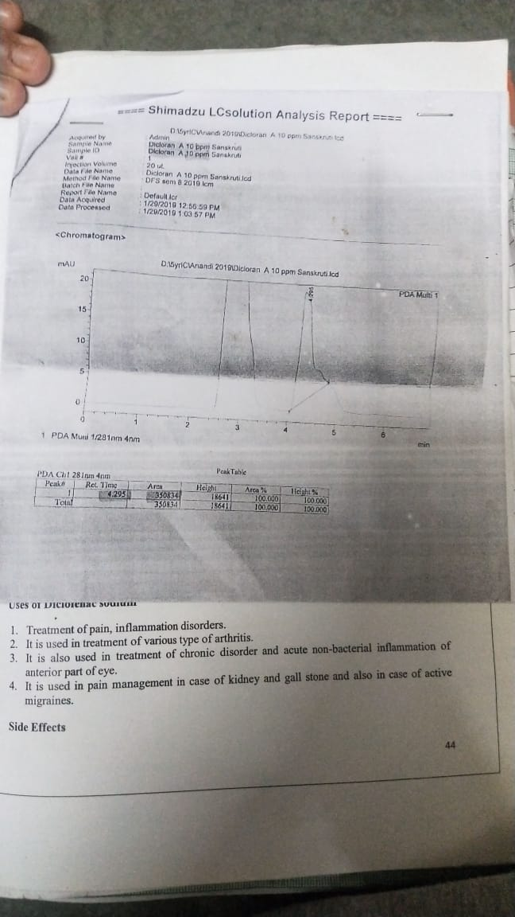

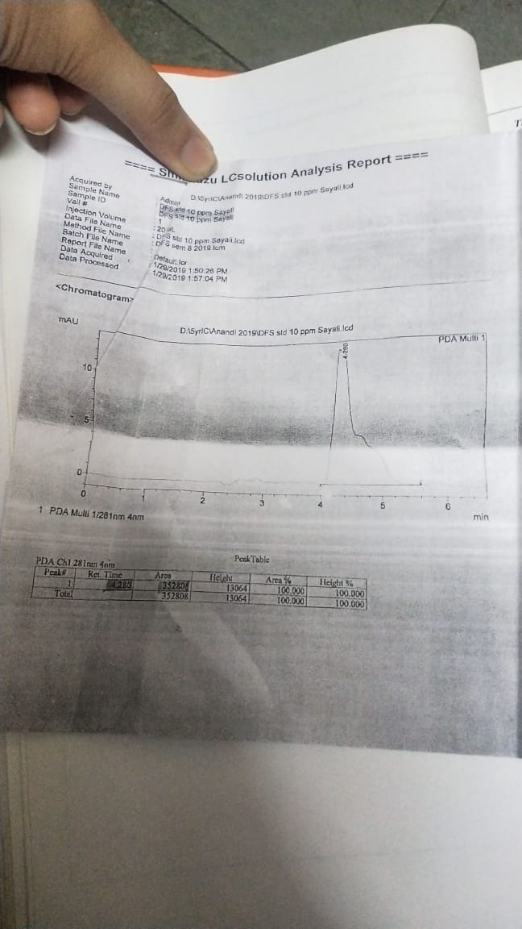

**PRACTICAL: 3**

**GAS CHROMATOGRAPHIC SEPARATION OF VOLATILE SAMPLE**

**DATE:22/07/22**

**AIM:**

To separate the components by gas chromatographic technique: Separation of methanol and ethanol

**INTRODUCTION:**

Gas chromatography is a term used to describe the group of analytical separation techniques used to analyse volatile substances in the gas phase. In gas chromatography, the components of a sample are dissolved in a solvent and vaporized in order to separate the analytes by distributing the sample between two phases: a stationary phase and a mobile phase. The mobile phase is a chemically inert gas that serves to carry the molecules of the analyte through the heated column. Gas chromatography is one of the sole forms of chromatography that does not utilize the mobile phase for interacting with the analyte. The stationary phase is either a solid adsorbant, termed gas-solid chromatography (GSC), or a liquid on an inert support, termed gas-liquid chromatography (GLC). Gas chromatography is an instrumental technique used forensically in drug analysis, arson, toxicology analyses of other organic compounds.

Diclofenac is a nonsteroidal anti-inflammatory drug (NSAID). This medicine works by reducing substances in the body that cause pain and inflammation. Diclofenac is used to treat mild to moderate pain, or signs and symptoms of osteoarthritis or rheumatoid arthritis. Voltaren is also indicated for the treatment of ankylosing spondylitis. The Cataflam brand of this medicine is also used to treat menstrual cramps.

Diclofenac powder (Cambia) is used to treat a migraine headache attack. Cambia will only treat a headache that has already begun. It will not prevent headaches or reduce the number of attacks.

**PRINCIPLE:**

In gas-solid chromatography, solid adsorbent is used as a stationary phase & separation takes place through adsorption process while in gas- liquid chromatography, the stationary phase consists of thin layer of non-volatile liquid bound to solid support & separation takes place through the process of partition. Gas-liquid chromatography is most commonly used technique. The sample which is to be separated is first converted into vapours & thus mixed with gaseous mobile phase. Components of a sample that are more soluble in stationary phase travels slower & the components that are less soluble in stationary phase travels faster. The components are thus separated according to their partition co-efficient.

**INSTRUMENTATION:**

Generally, all the chromatographs (GSC or GLC) consists of six basic components:

1. Sample injection system: A sample port is necessary for introducing the sample at the head of the column. A calibrated microsyringe is used to transfer a volume of sample through a rubber septum and thus into the vaporization chamber. Most of the separations require only a small fraction of the initial sample volume and a sample splitter is used to direct excess sample to waste. Commercial gas chromatographs involve the use of both split and splitless injections when alternating between packed columns and capillary columns. The vaporization chamber is typically heated 50 °C above the lowest boiling point of the sample and subsequently mixed with the carrier gas to transport the sample into the column.
2. Carrier Gas: A carrier gas plays a vital role in GC. It should be inert ,dry & free of oxygen. Helium, Nitrogen, argon & hydrogen gases are used as carrier gas depending upon the desired performance & detector being used. Carrier gas is supplied at high pressure & is passed to instrument at a rapid & reproducible rate.
3. Separation column: Open tubular columns or capillary columns & packed columns are used in GC. The first type of capillary column is a wall-coated open tubular (WCOT) column and the second type is a support-coated open tubular (SCOT) column. WCOT columns are have a thin layer of the stationary phase coated along the column walls. In SCOT columns, the column walls are first coated with a thin layer of adsorbant solid, such as diatomaceous earth, a material which consists of single-celled, sea-plant skeletons. The adsorbant solid is then treated with the liquid stationary phase. While SCOT columns are capable of holding a greater volume of stationary phase than a WCOT column due to its greater sample capacity, WCOT columns still have greater column efficiencies. One of the most popular types of capillary columns is called the coated Fused Silica open tubular column.
4. Column Oven or Thermostat chambers: The thermostat oven is there to control the temperature of the column to conduct precise work. The oven can be operated in two manners: isothermal programming or temperature programming. In isothermal programming, the temperature of the column is held constant throughout the whole separation. In the temperature programming method, the column temperature is either increased continuously or in steps as the separation progresses.
5. Detectors: Most common types of detectors used in GC are: Mass Spectrometer, Flame ionization detector (FID), Electron capture detector (ECD), Thermal conductivity detector (TCD), Atomic emission detector (AED), Photoionization detector (PID), Chemiluminescence detector. Detector is present at the end of the column & gives the quantitative measurement of the components of the mixture as they elute in combination with the carrier gas.
6. Amplification & Recorder system: These are the last & final components of GC instrumentation. These are meant to record the signals that come from the detector. These use special electronic circuits the process & amplify the signals so as to display in an understandable graphical format that represents several peaks of the constituents of the sample under analysis
7. Carrier Gas Types: Carrier gas is an inert gas used to carry samples. Helium (He), nitrogen (N2), hydrogen(H2),andargon(Ar)areoftenused.  
   Helium and nitrogen are most commonly used and the use of helium is desirable when using a capillary column.

|  |  |
| --- | --- |
| **Helium** | Although expensive, it is safe and has a relatively wide optimum linear velocity range. |
| **Nitrogen** | Although it is safe and its cost is reasonable, it has disadvantages such as a narrow optimum linear velocity range and a low optimum linear velocity that requires more analysis time. |

As carrier gas constantly flows into the detector, high-purity gas of at least 99.995 % needs to be used.

**SOFTWARE USED:**

GC-2014 Analysis Systems

**APPLICATIONS:**

GC has wide range of applications in various fields. It has a medicinal & pharmaceutical application. It is used in food, beverage, flavour & fragrance analysis. It is also helpful in environmental analysis and monitoring. It is used to detect doping of drugs. In forensics, it is used in cases of arson, detection of body fluids, for the testing of fibre, blood alcohol, detection of poisons, pesticides & also to detect explosives residues. It is also useful in Security and chemical warfare agent detection.

**The application of gas chromatography to environmental analysis**: GC has significant role in the identification & quantification of pollutants of environment. Capillary GC is used in the analysis of various classes of persistent organic contaminants in air, water, soils, sediments and biota. The organic pollutant groups like volatile organic compounds (VOCs); polycyclic aromatic hydrocarbons (PAHs); pesticides; and halogenated compounds such as polychlorinated dibenzo-p-dioxins and dibenzofurans, polychlorinated biphenyl, terphenyls, naphthalene and alkanes, organochlorine pesticides, and the brominated flame retardants, polybrominated biphenyls and polybrominated diphenyl ethers are analysed by GC.

**Application of gas chromatography in food analysis**: Gas chromatography (GC) is widely used in food analysis. Quantitative and qualitative analysis of food composition, natural products, food additives, flavor and aroma components, a variety of transformation products and contaminants, such as pesticides, fumigants, environmental pollutants, natural toxins, veterinary drugs, and packaging materials are done through GC.

**Application of GC in catalysis**: Determination of the physicochemical properties of solid catalysts and adsorbents, catalyst evaluation and kinetics of catalytic reactions, and study of catalytic reactions are done under chromatographic conditions. GC is 110 longer to be regarded merely as an analytical tool for the quick (and, if necessary, continuous) determination of product composition, but as an essential part of an integrated program of kinetic analysis, including the determination of reaction parameters as well as diffusional constants. GC can be used in the study of catalysis in two ways. In the first, the catalyst under study is packed in a chromatographic column, and the properties are estimated by the chromatographic parameters such as retention time, retention volume, band width and shape, and behavior of the chromatographic peak; while in the second, a micro reactor, in which a catalytic reaction or certain measurements on the catalyst are carried out, is directly connected to the chromatographic system whose function is to provide a rapid analysis of feed and products of the catalytic process.

**GC analysis of petroleum products:** The petroleum products such as jet fuel petrol, diesel, kerosene are also analysed through GC. Test parameters involves column- supeul –Q PLOT, oven-35 degree celsius, 16 degree per min. to 250 degree Celsius, detector – TCD, carrier gas – He ,sample-jet fuel. GC analysis of water ib gasoline is also done.

**OTHER COMMON APPLICATIONS:**

* Identification of hazardous compounds in waste damps.
* Quantification of drugs & their metabolites in blood & urine for both pharmacological &
* forensic applications.
* Identification of reaction products.
* Quantification of pollutants in drinking & waste water.
* Analysis of industrial products for quality control.
* Skin sample analysis.
* RNA isolation.
* Astro chemistry & geochemical search

**OBSERVATIONS:**

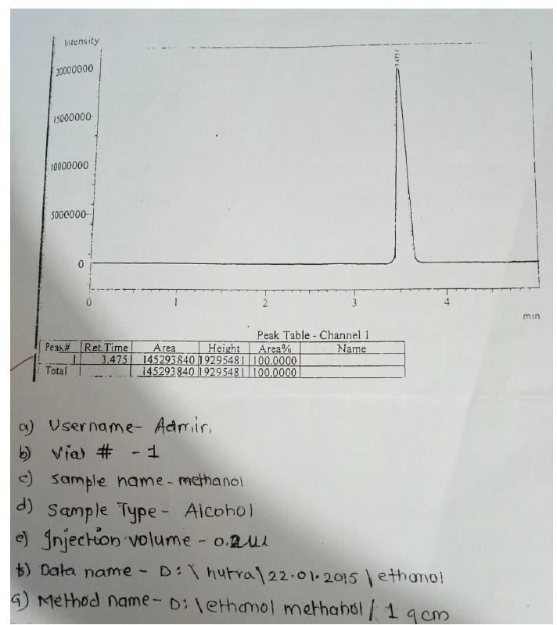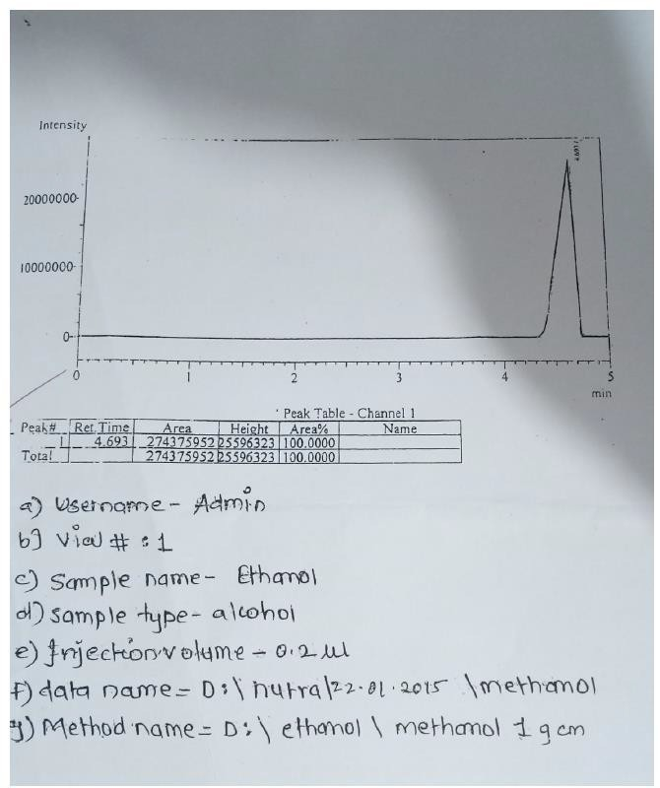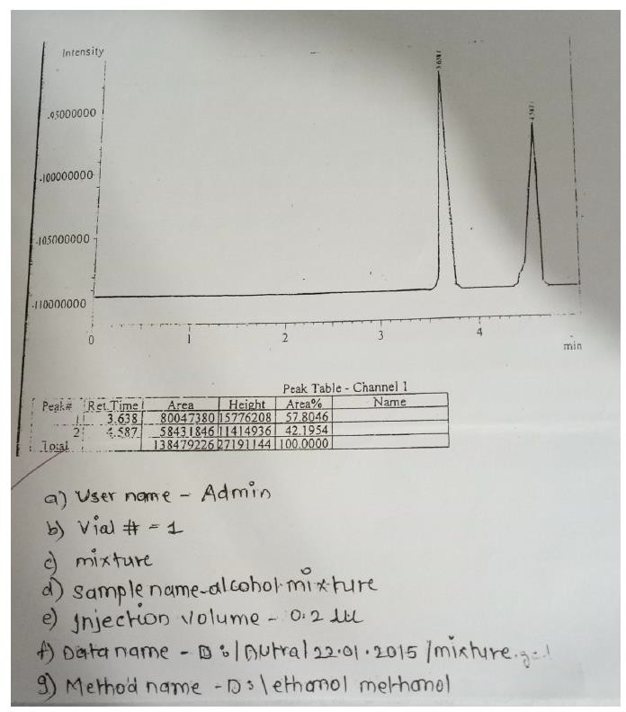

**RESULT:**

In the mixture of alcohol, Rt of peak 1 match with that of standard methanol and peak 2 matches with that of standard ethanol. Since, under the identical chromatographic conditions, the Rt of the individual solutes in the given mixtures is matching with that of standard. It can be concluded that peak 1 is of methanol and peak 2 is of ethanol. Thus, the mixture of closely related volatile alcohol was successfully separated by GC. The individual solvents were identified from the mixtures by matching the Rt values with that of standard.

**CONCLUSION:**

Thus, it can be concluded that at present, GC is the most widely used analytical technique available for separations & identifications of compounds or complex mixtures. The factors that makes GC most widely used technique are its speed, good resolving power, sensitivity with few mg of sample, good precision & accuracy.

# PRACTICAL NO. 4

**IR ANALYSIS OF A MODERN DRUG**

## **DATE: 30/09/22**

# AIM:

To obtain infrared spectra of Diclofenac Sodium using Fourier Transform Infrared Spectroscopy (FTIR).

# INTRODUCTION:

FTIR is commonly used for qualitative analysis. It can characterize nature of strong interaction; it can also determine fraction of interacting group in certain H bonded system. It is possible to find the IR spectrum of sample in various states like solid, liquid or gas. Material that is opaque to IR radiation must be diluted or dissolved in transparent matrix in order to obtain spectra. There are special accessories like liquid cell for that matter. The technique is based on a simple fact that a chemical substance shows a selective absorption in infrared region. After absorption of IR radiation, the molecule of chemical substance vibrates at different rate of absorption, giving rise to close peak absorption band called as an ‘IR absorption spectrum’. This spectrum may extend over wide wavelength range. Three various bands will absorb in IR spectrum which will correspond to characteristic functional group and band present in chemical substance. The IR region is divided in 3 regions:

1. Near IR: Wavelength range is approximately 12800 - 4000 cm-1 this region is called high energy near IR. Sample containing moisture can be detected in this group.
2. Mid IR: Wavelength range is approximately 4000 - 200 cm-1, this region may be used to study the fundamental vibrations and associated rotational vibrational structures.
3. Far IR: Wavelength range is approximately 200 – 10 cm-1, this wave is placed before the microwave region. It has low energy and used for rotational spectroscopy before 400 cm-1.

|  |  |  |
| --- | --- | --- |
| TYPE | WAVELENGTH | NUMBER (cm-1) |
| Near IR | 0.78 -2.5 | 12800-4000 |
| Mid IR | 2.5-5.0 | 4000 - 200 |
| Far IR | 5.0-1000 | 200 – 10 |

As infrared spectrum represents, a fingerprint of sample with absorption peak. Since each material consist of a unique combination of atom. No two compounds produce identical spectra. Thus, the IR spectrum of a chemical substance is a fingerprint for its identification. Hence it is a good analytical tool and can be used for different materials. An IR spectroscopy is based on change in the vibrational energy of a molecule when it is exposed to IR region molecule absorbs the specific frequencies that are characteristic to their structure. These frequencies of absorbed radiation match with frequency of the band on group that vibrate in the molecule in order to molecule to be IR active change in vibrational energy should take place, which is associated with change in permanent dipole moment of atom in the molecule. A molecule can vibrate in different ways and

each way is called a vibrational mode. For the molecule with ‘n’ number of atoms in it a linear molecule is shown to have 3n-5 degree of vibrational mode where non-linear molecule is [shown to have 3 -6 degree of vibrational mode. A simple diatomic molecule has only one band and only one vibrational mode. If molecule is symmetric like N2 the band is not observed in the IR spectrum, but only in Raman spectrum only asymmetric molecule like CO2 absorbs in the IR spectrum. The atom on the CH2X2 group , commonly found inorganic compound where ‘x’ can represent any other atom, can vibrate in different way. Six of this vibration can occur in the CH2 group itself are as follow :

* 1. Symmetrical stretching
  2. Asymmetrical stretching
  3. Scissoring
  4. Rocking
  5. Wagging
  6. Twisting

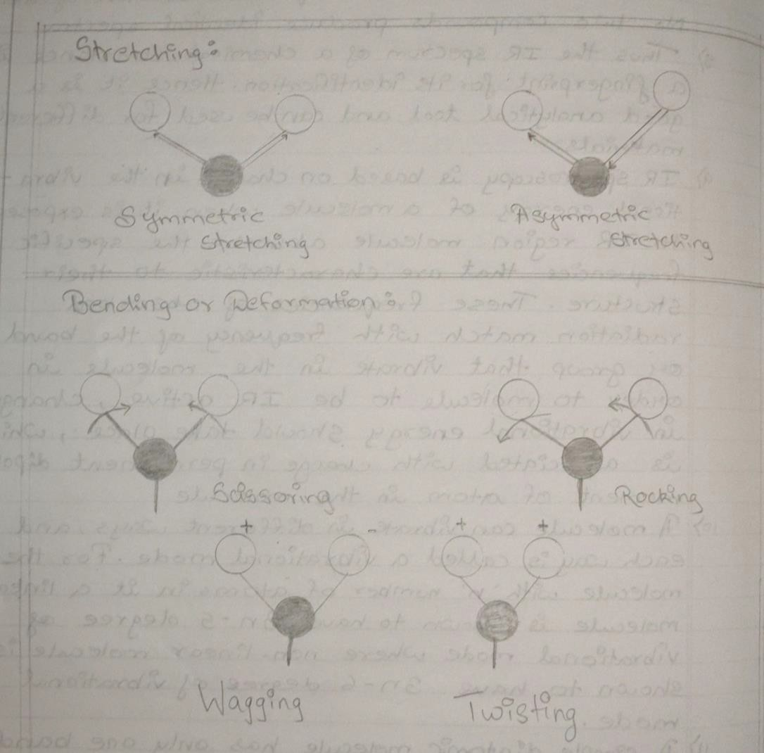

# PRINCIPLE :

IR spectroscopy is used to study the interaction between matter and electromagnetic field in IR region. In this spectral region the electromagnetic wave mainly couples with molecular vibration. In other word, molecule can be excited to higher Vibrational state by absorbing IR radiation The probability of a particular IR frequency being absorb depend on the actual interaction between frequency and the molecule. In general, a frequency will strongly absorb in photon energy coincide with vibrational energy level of molecule.

### **INSTRUMENTATION OF FOURIER TRANSFORM INFRARED SPECTROSCOPY**

Instrument consists of 5 parts:

1. Source
2. Interferometer
3. Sample holder
4. Detector
5. Recorder

## **SOURCE:**

IR source consists of an inert solid that is heated electronically to a temperature between 1500- 2000K. IR energy is emitted from a glowing black body source. These are different types of sources in FTIR spectroscopy.

**Nerst Glober:** It is fabricated from rare Earth oxide (eg ZrO2, I2O2) temperature range is 1200- 2200K.

**Globar:** It is in the form of silicon carbide rod, which is 50mm in length and 5mm in diameter and heated at 1300 – 1500K.

**Incadescent Wire Source:** Nichrome or Rhodium wire is electrically heated at 1200-1000K.

**Carbon Dioxide Laser:** CO2 laser gas mixture consist of 70 % Helium , 15%. CO2 and 15% N2 this source is much more intense than black body sources.

**Mercury Arc:** It is used in far IR region (λ > 50 µm).

**Tungsten Filament:** It is used the near IR region (2.5 – 0.7 µm).

## **INTERFEROMETER:**

It works on the principle of Beer Lambert's Law. It is also referred to as a Michelson's interferometer. The light from the source, it is split by central mirror or beam splitter into two beams of equal intensities. The reflected beam goes to the fixed mirror and other to the moving mirror. The reflected light by beam splitter recombines and passes through sample eventually to the detector. Thus, the interferogram is produced.

## **SAMPLE HOLDER:**

It holds the sample; the beam enters in the sample compartment where it is transmitted through or reflected off the surface of the sample depending on the type of analysis being accomplished. This is where specific frequency of energy which are uniquely specific to a sample are absorbed.

## **DETECTOR:**

The beam finally passes through the detector for final measurement. The detectors used are specifically designed to measure the special interferogram signal. Many different types of detectors are used which are as follow :

1. Thermal detector
2. Photo conducting detector
3. Pyroelectric detector

## **COMPUTER RECORDER**:

The measure signal is digitalized and send to the computer when the fourier transformation take place. The final infrared spectrum is then presented to the user for interpretation and further manipulation.

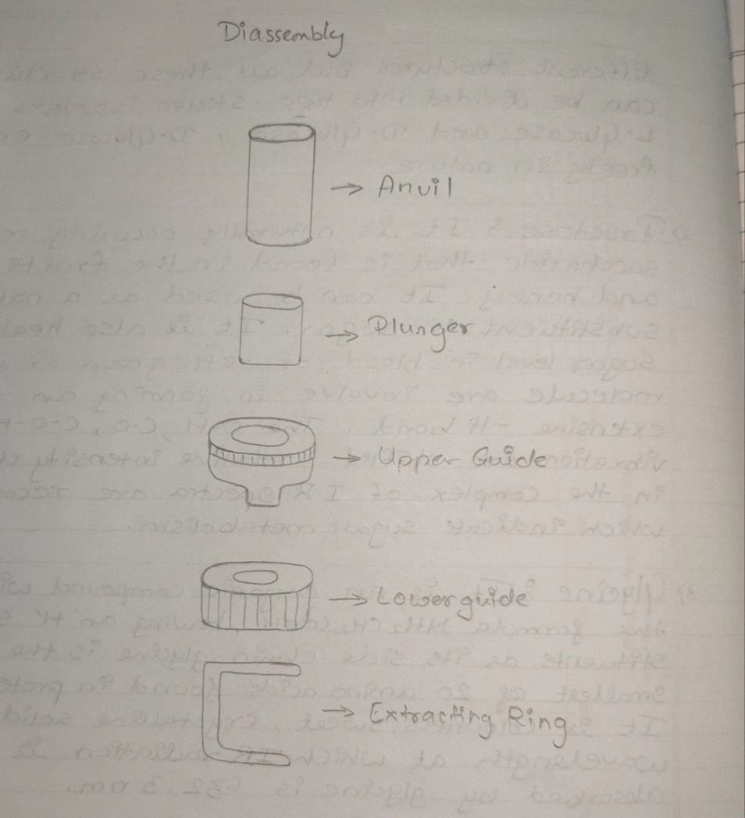

**Michelson’s Interferometer**

FTIR spectroscopy consist of an instrument which is known as Michelson's interferometer. This instrument observes the rule of Beer Lambert law. The basis of Michelson's interferometer consists of:

* A broad band light source which emits light in mid IR region.
* A beam splitter made up of CsI and KBr.
* A specific detector.
* Two front surface coated mirror - one moving and one fixed.

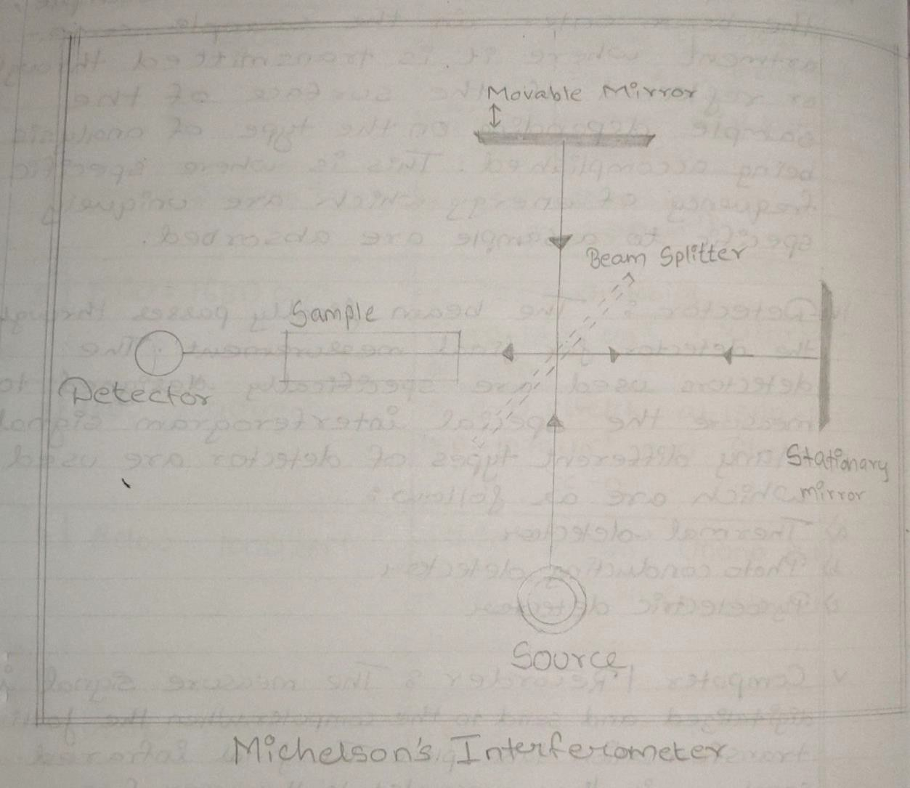

**Working principle of Michelson’s Interferometer:**

Light from the light source is directed to the splitter. Half of the light is reflected and half of light is transmitted through splitter. Reflected light goes to the fixed mirror, where it is reflected back to beam splitter. The transmitted light is sent to moving mirror and is also reflected back to beam splitter. At the beam splitter, each of two beams are split into two. One goes back to light source and other goes towards the detector. Hence the detector detects, two beams one from moving mirror and other from fixed mirror. The beam reaching the detector come from the same source and have an optical path

difference determined by the position of two mirror i.e., they have a fixed phase difference in two beam interferences. If a mirror is scanned over a range , a sinusoidal signal will be detected from frequency, with the maximum and minimum corresponding to constructive and destructive interference respectively. The signal is called as "INTERFEROGRAM.

**Advantages of FTIR**

* Universal Technique
* Sensitivity 10-6 grams
* Fast and easy
* Relatively an expensive
* Majority of molecule absorb mid IR radiation making it highly useful tool

Advantages of FTIR over Dispersive IR:

* **Felgett advantages**: Because all of the frequencies are measured simultaneously, most measure of FIIR are made in few seconds.
* **Jacquinot throughput advantages**: Sensitivity is dramatically improved with FTIR for many reasons, the detector employed are much more sensitive. The optical throughput is much higher which result in the lower noise level and scan in order to reduce the random measurement noise to any desire level.
* In the instrument, there are fewer possibilities of mechanical breakdown since the moving mirror is the part of instrument.
* This instrument is self-calibrated and never needs to be calibrated by user.

**Applications of FTIR:**

* It is useful in identifying substances and confirm their identity.
* This spectroscopy has been highly successful for the application to organic chemistry.
* It is used in both research and industries as simple and reliable technique for quality control and dynamic measurement.
* It is successfully utilized in the field of semiconductor. Micro-electronic like silicon, zinc selenide, galium nitride , silicon nitride amorphous silicon etc.

**Use of potassium bromide (KBr) in FTIR**

The pellet preparation method in PIIR explain the property that alkali halide becomes transparent when subjected to high pressure and form a sheet that is transparent on the IR region. KBr is used because it does not absorb at any infrared radiation in the region of 4000-650 cm-1. KBr is inert in nature and it does not react with sample to be analyzed. It helps in better resolution of beam of analyte as it does not show any absorbance in any region. It is also highly stable, so the background scanned once can be used for a longer duration of analysis. Cesium Iodide (CsI) can also be used to measure

in the infrared spectrum in the 4000 - 250cm-1 region but generally it is prevented as it is costly than KBr.

**Samples analysed using FTIR**

* Diclofenac Sodium (DFS): DFS is a non-steroidal , anti-inflammatory drug taken to reduce the inflammation and analgesic to reduce pain in certain condition. It is available as generic drug in number of formulations like tablet, injection, etc. It is yellowish hydroscopic crystalline powder, soluble in alcohol. It is useful in treatment of arthritis, rheumatoid, osteoarthritis and in treatment of chronic.

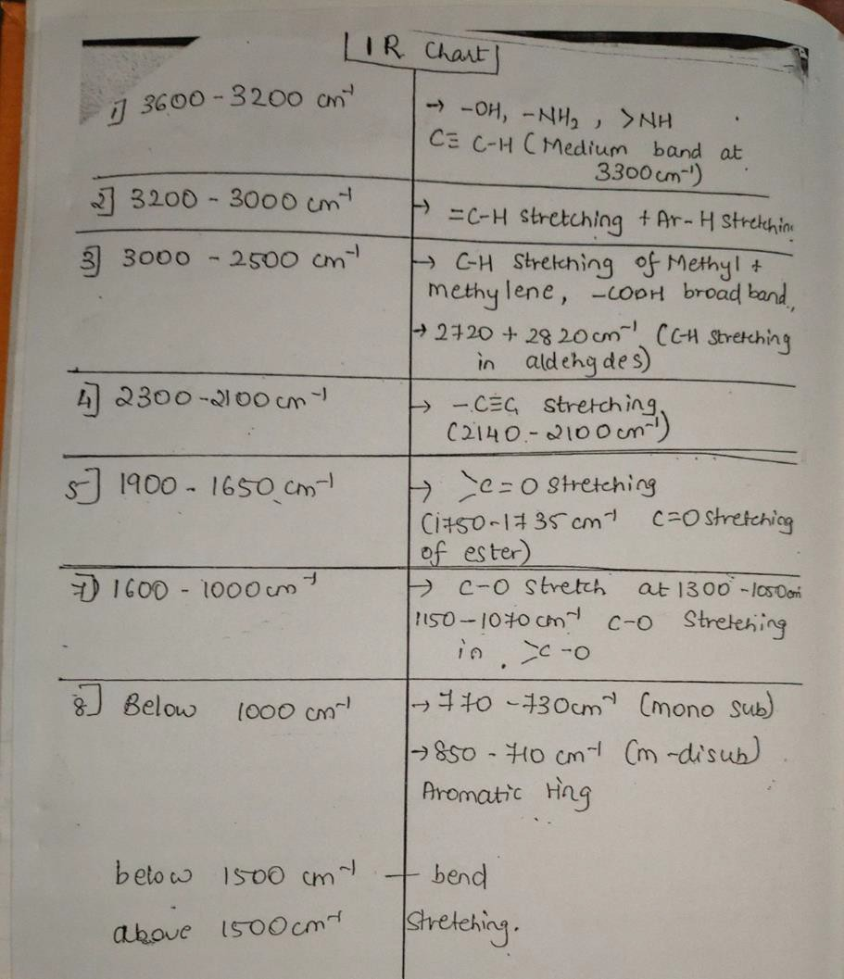

# REQUIREMENTS:

* Glasswares:
  1. Beaker
  2. Petriplate
* Chemicals:

1. Chloroform
2. Potassium Bromide (KBr)

* Sample:

1. Diclofenac Sodium (DFS)

* Instruments:

1. Shimadzu FTIR; Model no. IR Affinity-1
2. Source: High energy ceramic filament
3. Interferometer: Michelson’s interferometer
4. Detector: Pyroelectric detector

* Miscellaneous:

1. Pellet preparation assembly:
   1. Die assembly (Bottom guide, top guide, plunger, anvil)
   2. Extraction ring
   3. Hydraulic press pump
2. Sample holder
3. Spatula
4. Mortar and pestle
5. Oven dry box
6. Tissue paper
7. Data recorder

# PROCEDURE:

1. Clean the mortar and pestle with chloroform.
2. Add KBr and Diclofenac sodium (DFS) into pestle and mortar with the ratio 98:2 & crush mixture into fine powder.
3. Clean the anvil and plunger with chloroform to remove impurities.
4. Assemble top and bottom guide and insert the anvil with polish surface upwards in the apparatus.
5. Fill the sample carefully inside the cavity of die assembly apparatus
6. Insert the plunger with polish surface facing downwards.
7. Transfer the die assembly to the hydraulic pressure pump and apply pressure on hydraulic pump.
8. Apply constant pressure of 10 tons for 10 minutes.
9. After 10 minutes remove pellet assembly from hydraulic pump.
10. Remove the bottom guides existing using extraction ring by as applying pressure from reverse side to remove the pellet.
11. Transfer the pellet carefully to the sample holder in the FTIR machine and record the spectrum.

* **DICLOFENAC SODIUM (DFS) SPECTRUM**

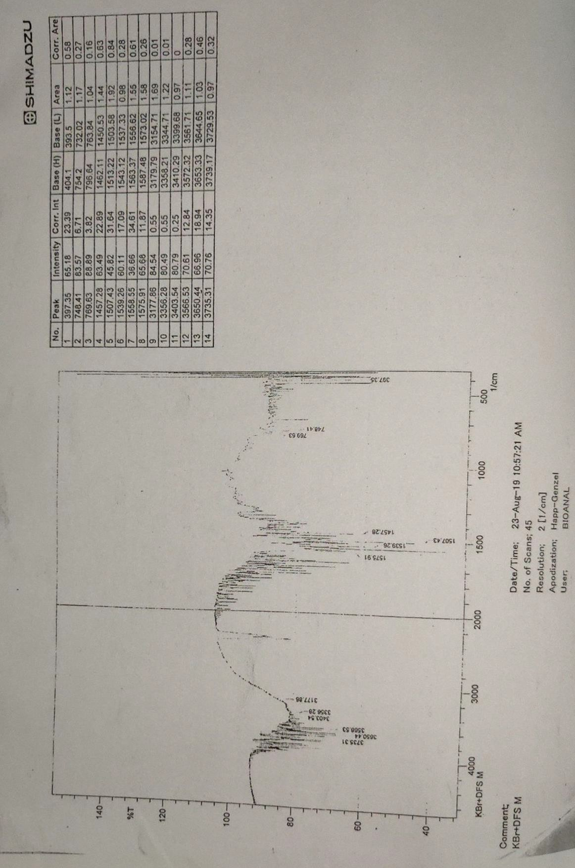

# OBSERVATION TABLE:

* + **DICLOFENAC SODIUM**

|  |  |  |
| --- | --- | --- |
| **Functional Group** | **IR Range (cm-1)** | **Peak (cm-1)** |
| -OH, -NH, >NH2,  C≡C-H (Medium bond at 3300 cm-1) | 3600 - 3200 cm-1 | 3356.23, 3403.54, 3566.53 |
| =C-H Stretching + Ar-H Stretching | 3200-3000 cm-1 | 3177.65 |
| C-O stretch at 1300 -1050  cm-1, 1150-1070 cm-1  C-O stretching in =C-O | 1600-1000 cm-1 | 1575.91, 1553.55, 1539.25,  1507.43, 1457.28 |
| 770-730 cm-1 (mono sub ) 850-710 cm-1 (m-disub) aromatic ring | Below 1000 cm-1 | 769.53, 748.41, 397.35 |

# RESULTS:

1. Intact pellets of KBr-DFS were prepared using pressure pump.
2. The interferograms were obtained specifically for the samples after the FTIR analysis.
3. The interferograms were correlated using co-relation charts and the reference interferograms.
4. On the other hand, functional groups such as -OH or amines, C-H stretching, C-O stretch were detected in the DFS spectrum.

# CONCLUSION:

The infrared spectrum of Diclofenac Sodium (DFS) were obtained successfully using Fourier Transform Infrared Spectroscopy (FTIR). FTIR is one of the sensitive methods which depends on the principle of Beer-Lambert law. Using this instrument, one can elucidate the functional groups present in the compound using reference charts. However, FTIR along with conjugation of other techniques would be required to confirm the compound of interest.